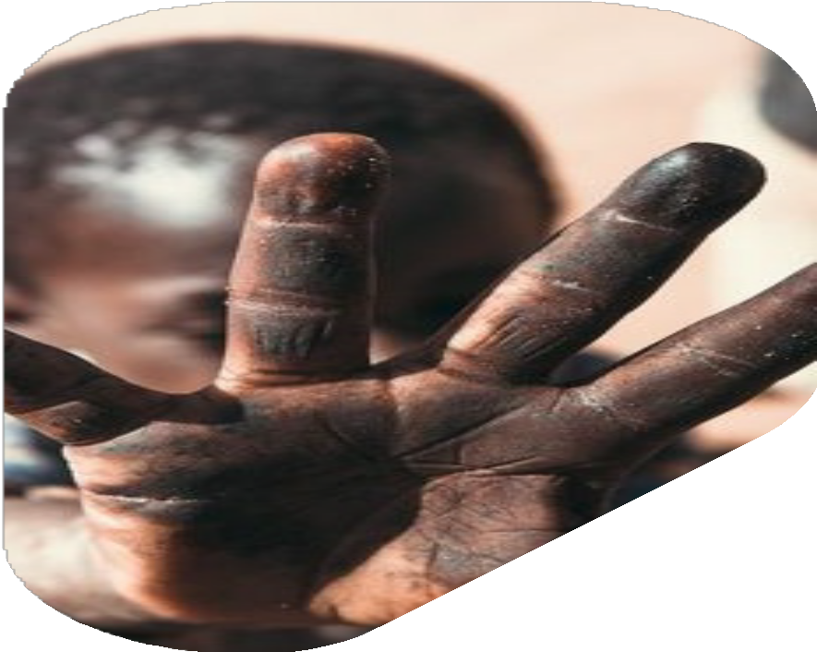

**POLICY BRIEF**

**ON CHILD LABOUR IN THE NIGERIAN EXTRACTIVE SECTOR**

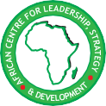



**POLICY BRIEF**

**ON CHILD LABOUR IN THE NIGERIAN EXTRACTIVE SECTOR**

@

AFRICAN CENTRE FOR LEADERSHIP, STRATEGY & DEVELOPMENT

**Cii§\0§611)8**



01

02

09

11

**Acknowledgement**

W

e want to begin by specially appreciating Almighty God for His mercy, sustenance, and for being gracious to us as a people and as a Centre. We lay it to heart and we return all the glory

and adoration to His holy name.

To the Ford Foundation, we also register our gratefulness. This research report was made possible through the generous support of the Ford Foundation BUILD grant. The two components of the grant, institutional and programmatic were a great value-add and a turning point to our programming experience at the Centre.

We extend our sincere appreciation to the research team, led by Professor Peter Terkaa Akper, SAN, OFR, and the technical assistants: Dr. Izuoma Egeruoh-Adindu, Dr. Laura Ani, and Ms. Adejoke Adediran, whose expertise and dedication were instrumental to the success of this project.

We also acknowledge the efforts of Mr. Vincent Dania, the project manager, for his exceptional coordination and support in ensuring the timely and smooth delivery of this report.

Our gratitude extends to Mr. Monday Osasah, FSM, Executive Director; Dr. Otive Igbuzor, Founding Executive Director; Dr. Margaret Fagboyo, Director of Development; and the entire staff and management of the African Centre for Leadership, Strategy & Development (Centre LSD) for their guidance and unwavering commitment.

You are the best!

October 2024









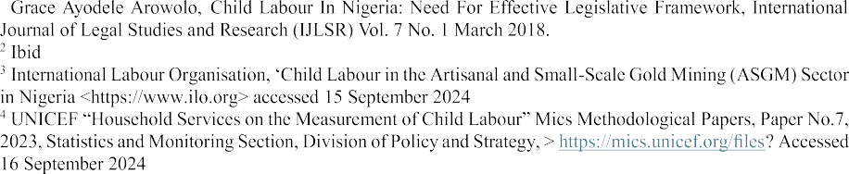









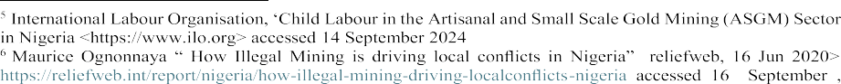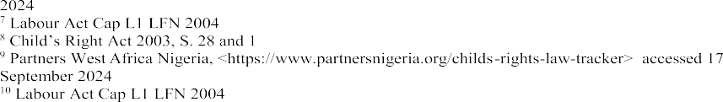

**02**













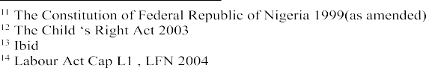

**03**









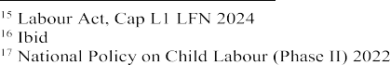

















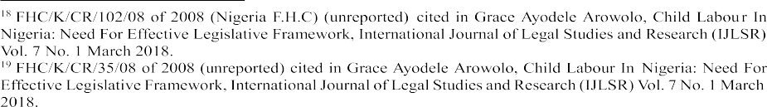

















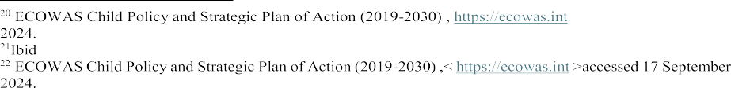



















































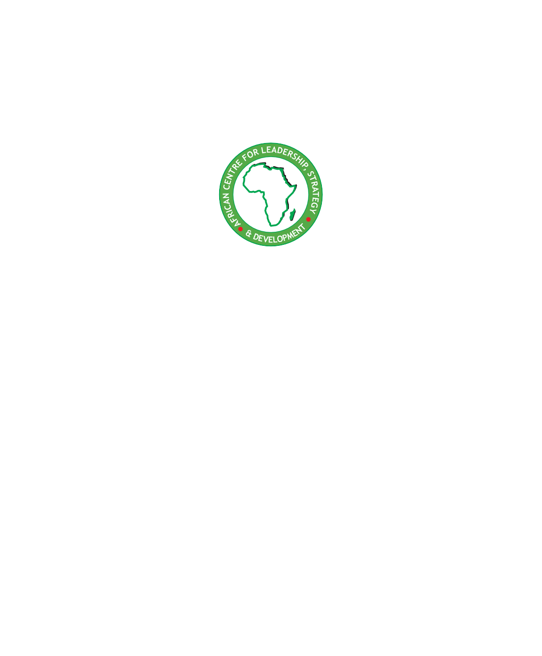

**Headquarters:**

3B, Niger Avenue, Villa Nova Estate, after Cedar Crest Hospital,

Apo Dutse, Abuja.

**Niger Delta Office:** Odeyovwi Villa, Emonu-Orogun, Ughelli North LGA, Delta State.

**Northern Regional Office:**

NO. 220-221 Police Shop, Waziri street, Opposite Murtala Mohammed College, Jimeta, Yola, Adamawa State.

* 08122556434
* @centrelsd **O** @centrelsd

centrelsd.org

**ISBN:**